REGISTRATION
Abstract submission and participant’s registration are provided on the following address: http: vpb2016.kgasu.ru by using interactive bulletins till 18 September, 2016.
Registration by mail, e-mail, phone call and fax messages are impossible.
Registration procedure is needed only for participants and Organization committees, see conditions on topic “Conference participants”, http: vpb2016.kgasu.ru

ARTICLES PUBLICATION
All abstracts will be published before Conference as Proceedings. Up to end of Conference its Materials (e.g. oral and Plenary reports) will have been published after peer-reviewing in News of KSUAE by Program Committee’s decision or in journals which provide information support for Conference, viz “Building Materials”, “Concrete and Reinforced Concrete”, “Cement and its Applications”, “Industrial and Civil Engineering”.

ABSTRACT GUIDELINES
Abstracts should be submitted in Russian or English, volume of abstract – 1 page A4. Sample abstract and guidelines are on Conference web page: http: vpb2016.kgasu.ru, e-mail: vpb2016-kgasu@mail.ru
Only two abstracts could be sent from one Conference participant!
Abstracts will be published in author’s edition! Details of the format of full manuscripts will be distributed to the authors of accepted for further abstracts

CONFERENCE LANGUAGES
Russian, English.

REGISTRATION FEE
Types of registration:
Full registration – 4.500 RUR
For organizations’ and enterprises’ members – 7.000 RUR
Postgraduates, students – 1.500 RUR
Correspondence participation – 1.000 RUR
Bank details for fee payment are published on Conference’s web page. Fee includes participation in all sessions, proceedings publishing, excursions, coffee breaks.
Accommodation should be provided and paid by participants.
Fee’s payment should be done till 19 September, 2016.

EVENTS OF CONFERENCE
In terms of Conference, the following events are planned:
- Plenary and sectional reports
- Young scientists contest
- Excursion program.

KEY DATES
17 June, 2016 – start for Conference application form filling;
18 September, 2016 – end for Conference abstract submitting;
19 September, 2016 – fee’s payment deadline;
24-25 October, 2016 – registration for Conference participants in KSUAE.
HSC-2016 Conference will be held in Kazan State University of Architecture and Engineering from 25 to 27 October, 2016 on the following address: 420043, Russia, Republic of Tatarstan, Kazan, Zelenaya str., 1.
Conference Secretary: Dr. Morozov Nicolay, Dr. Krasinikova Natalya.
Phone number: +7(843)510-47-34,
e-mail: vpb2016-kgasu@mail.ru

Department of Architecture, Engineering and Housing of Republic of Tatarstan
Republic of Tatarstan President’s Office
Non-profit organization “Republic of Tatarstan President’s State Housing Foundation”
International Federation for Structural Concrete (fib) National Group
The International Union of Laboratories and Experts in Construction Materials, Systems and Structures (RILEM)
Regional Group
Structural Concrete Association
State Unitary Enterprise “Tatinvestgrazhdanproject”
Public Society “Kazan Giproniiaviaprom”
Kazan State University of Architecture and Engineering

International Scientific-Technical Conference

High-strength cement concretes: technologies, constructions, and economics (HSC-2016)
http: vpb2016.kgasu.ru

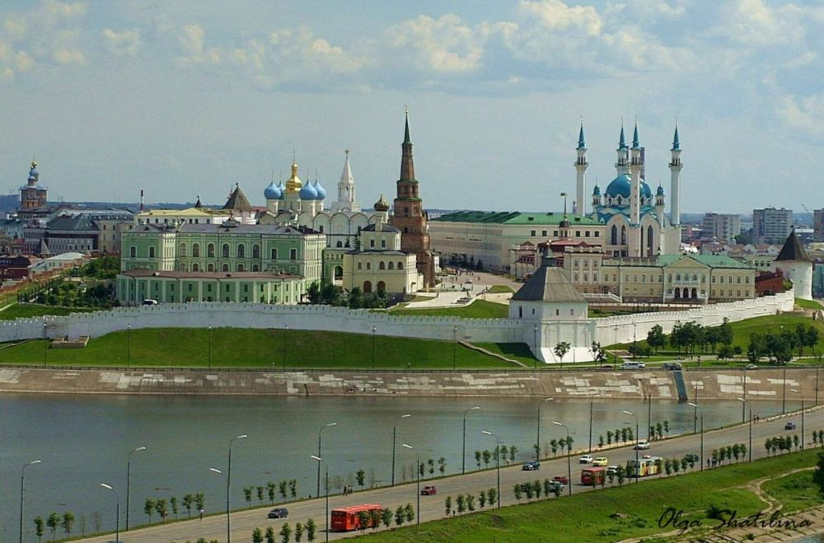

Russia, Kazan, KSUAE
25-27 October, 2016

Dear Colleagues!
We sincerely invite you to take participation in International scientific-technical Conference “High-strength Concrete”, which will be organized in Kazan State University of Architecture and Engineering from 25 to 27 October, 2016.
The aim of the Conference is to exchange ideas in concrete science, technology, high-strength concrete construction design achievements; to discuss and consolidate efforts for modern engineering efficiency improvement.

ORGANIZATION COMMITTEE
Chairman:
Rashit Nizamov – Professor, Ph.D. (Engineering), Rector of KSUAE.
Deputy chairmen:
Ireck Fajzullin – Ph.D (Economics), Head of Department of Architecture, Engineering and Housing of Republic of Tatarstan;
Farit Hanifov – Republic of Tatarstan President’s assistant;
Talgat Abdullin – CEO, Non-profit organization “Republic of Tatarstan President’s State Housing Foundation”;
Vadim Khozin – Professor, Head of Department of Construction materials, units and constructions, KSUAE, Ph.D. (Engineering);
Vyacheslav Falikman – Professor, 1-st vice-president of Structural Concrete Association, RILEM Regional Convener, Head of fib National Group, Doctor of material sciences.

International scientific committee:
Prof. Dr.-Ing. Viktor Mechtcherine, Director of Institute of Construction Materials, Faculty of Civil Engineering, TU Dresden, Germany, RILEM Bureau member;
Dr. Konstantin Sobolev, Associate Professor, Department of Civil Engineering and Mechanics, University of Wisconsin-Milwaukee, USA, Head of ACI 241 Technical Committee;
Dr. Arlindo Gonçalves, Head of Materials Department of National Laboratory for Civil Engineering (LNEC), Portugal, RILEM DAC member;
Prof. Gideon P.A.G. van Zijl, Director of Centre for Development of Sustainable Infrastructure, Department of Civil Engineering, Stellenbosch University, South Africa;
Prof. Liberato Ferrara, Politecnico di Milano, Department of Civil and Environmental Engineering, Italy;
Prof. Alva Peled, Ben-Gurion University of the Negev, Faculty of Engineering Sciences, Israel;
Prof. Koryun A.Karapetyan - Head of experimental of the laboratory, National Academy of Sciences Institute of Mechanics. Republic of Armenia.

Organization committee members:
Vladimir Kalashnikov - Head of Department of Construction materials, and Woodworking, PSUAE (city of Penza), Ph.D. (Engineering), Professor;
Semyon Kaprielov – Head of laboratory of NIIZHB, Ph.D. (Engineering);
Nikolai Karpenko – Professor, Head of laboratory of NIISF, Ph.D. (Engineering), academician of RAASN;
Valery Latypov – Professor, Head of Department of Engineering constructions, USPTU (city of Ufa), Ph.D. (Engineering);
Ilizar Mirsayapov – Professor, Head of Department of Bases, Foundations, Structural dynamics and Engineering geology, Ph.D. (Engineering);
Valery Morozov – Professor, Head of Department of Reinforced concrete and Stone constructions, SPSUAE, Ph.D. (Engineering);
Alexey Nefedyev – CEO, «Evrosintez» (City of Magnitogorsk), Ph.D. (Engineering);
Georgy Nikitin – Deputy Director, Public society “Kazan Giproniiaviaprom”, Ph.D. (Engineering);
Igor Ovchinnikov – Professor, full member of the Russian Engineering Academy, Ph.D. (Engineering);
Vladimir Selyaev – Professor, Head of Chair of Engineering constructions, Department of architecture and engineering, Ogarev Mordovia State University, academician of RAASN, Ph.D. (Engineering)
Alfred Syleymanov – Professor, vice-rector for Research, Head of Construction materials Department, Ph.D (Engineering)
Vladimir Travush – Chief constructor, Mezentsev ENPI, academician of RAASN, Ph.D. (Engineering).
Igor Kharchenko – Professor, Department of Binders and Concretes technology, Ph.D. (Engineering)
Grigory Yakovlev - Professor, Head of Department of Geotechnics and Construction materials, Mikhail Kalashnikov Izhevsk State Technical University, Ph.D. (Engineering)

CONFERENCE SECTIONS

I. High-strength concretes (structure, properties, technologies)
1. High-strength/High Performance concrete concepts development and technology specifics.
2. Self-consolidating fine-grain high-strength concretes.
3. Fiber-reinforced HSC.
4. Durability of HSC.
5. Prefabricated high-strength reinforced concrete production.
6. Test and control methods for HSC.
7. Issues of regulatory and technical base.

II. Efficient constructions from HSC.
1. Strength and deformations of HSC in case of short- and long-term tests.
2. Micromechanics of different types of HSC.
3. Experience and future perspectives of HSC using in monolithic constructions of high rise buildings, sport and unique constructions and buildings.
4. Efficient constructions made from HSC in transport and underground engineering – bridges, tunnels etc.
5. Thin-wall HSC constructions in basic-loaded shells, reservoirs, river constructions and pipes.
6. Architectural constructions made from HSC.

III. Production and utilization of HSC in constructions economy.
1. Resource and energy consumption reduction potential assessment and their role in construction industry innovative development.
2. HSC production and utilization in civil and industry engineering and infrastructure objects economy.
3. Life-cycle cost analysis of constructions made from HSC (production-assembling-exploitation-utilization).

